**Herbs Bazar**

**Software Requirements Specification**

Software Engineering Project

**Version 1.0**



**Group Id: 15**

**Group Members:** 2018-CS-89, 2018-CS-82, 2018-CS-55

**Supervisor Name:** Ms. Taliah Tajammal

Department of Computer Science

University of Engineering and Technology Lahore

**Table of Contents**

*1* Introduction 3

1.1 Scope 3

1.2 Glossary 3

1.3 Technologies to be used 3

2 General Description 5

2.1 User Characteristics 5

2.2 General Constraints 5

2.3 Assumptions & Dependencies 5

3 Specific Requirements 6

3.1 External Interface Requirements: 6

3.1.1 User Interfaces 6

3.2 Functional Requirements 6

3.2.1 User 6

3.2.2 Admin 6

3.3 Use Cases: 6

3.4 Non Functional Requirements: 17

4 Methodology 17

4.1 Adopted Methodology 17

4.2 Diagram of Methodology 17

4.3 Reason of Choosing Methodology 17

5 Project Work Plan 17

# Introduction

This document is meant to give a complete introduction to the scope, glossary and the technologies to be used in this project as well as provide a thorough analysis and in-depth insight for Online Herbs Bazar. It will also provide the information about the capabilities required to run the application successfully and define different high-level characteristics. This SRS will elaborate the target audience, interface and detailed requirements of the project.

## Scope

The scope is primarily concerned with features to make Online Herbs Bazar live. The project focuses on providing a user-friendly and smooth experience for potential customers to purchase products online. The SRS is also focused on identifying the requirements for designing a web application to provide a virtual window for customers to browse and purchase products. It will also provide design for administrator to add, update and delete products as well as modify status of the orders. This project is limited to admin adding and editing products and the users cannot sign up as vendor to sell their products. This SRS does not identify a specific module but is concerned with entire Online Herbs Bazar.

## Glossary

|  |  |
| --- | --- |
| Term | Definition |
| Stakeholder | Any person with an interest in the project who is not a developer. |
| User | System Actors- Users, Admin. |
| Manage | User (View, Add to Cart), Admin (Delete, Edit) |

## Technologies to be used

|  |  |
| --- | --- |
| Technology | Description |
| Microsoft Project Professional | Microsoft Project is a [project management software](http://en.wikipedia.org/wiki/Project_management_software) program, developed and sold by [Microsoft](http://en.wikipedia.org/wiki/Microsoft), which is designed to assist a [project manager](http://en.wikipedia.org/wiki/Project_manager) in developing a [plan](http://en.wikipedia.org/wiki/Plan), assigning [resources](http://en.wikipedia.org/wiki/Resource_(project_management)) to tasks, tracking progress, managing the [budget](http://en.wikipedia.org/wiki/Budget), and analyzing workloads. |
| Visual Studio | Microsoft Visual Studio is an integrated development environment from Microsoft |
| VS Code | Visual Studio Code is a free source-code editor made by Microsoft for Windows, Linux and macOS. Features include support for debugging, syntax highlighting, intelligent code completion, snippets, code refactoring, and embedded Git |
| Xampp | XAMPP is a free and open-source cross-platform web server solution stack package developed by Apache Friends, consisting mainly of the Apache HTTP Server, MariaDB database, and interpreters for scripts written in the PHP and Perl programming languages |

# General Description

## User Characteristics

The user classes of this system are:

-User

-Admin

The user classes should be sighted and of sound mind with knowledge of how to use computer and a basic understanding of English Language. More details are given below:

**User:**

The User can view and browse products available. User can also add and delete products from cart and checkout as well as login and register.

**Admin:**

Admin can add categories available on website as well as products. Admin can also delete and edit the products and categories. Admin can also manage the orders and check the history of orders placed. Admin can check the registered accounts and delete them.

## General Constraints

This project allows requires basic computer and English language knowledge requirements. The project also requires internet connection to work.

## Assumptions & Dependencies

* Users should have stable internet connection.
* System should be able to place order at any time.
* An order placed cannot be cancelled.
* Server should run all the time.
* System should not lose any information at any time.
* Products available should be updated on time and those not available as well.

# Specific Requirements

## External Interface Requirements:

### User Interfaces

Admin Dashboard

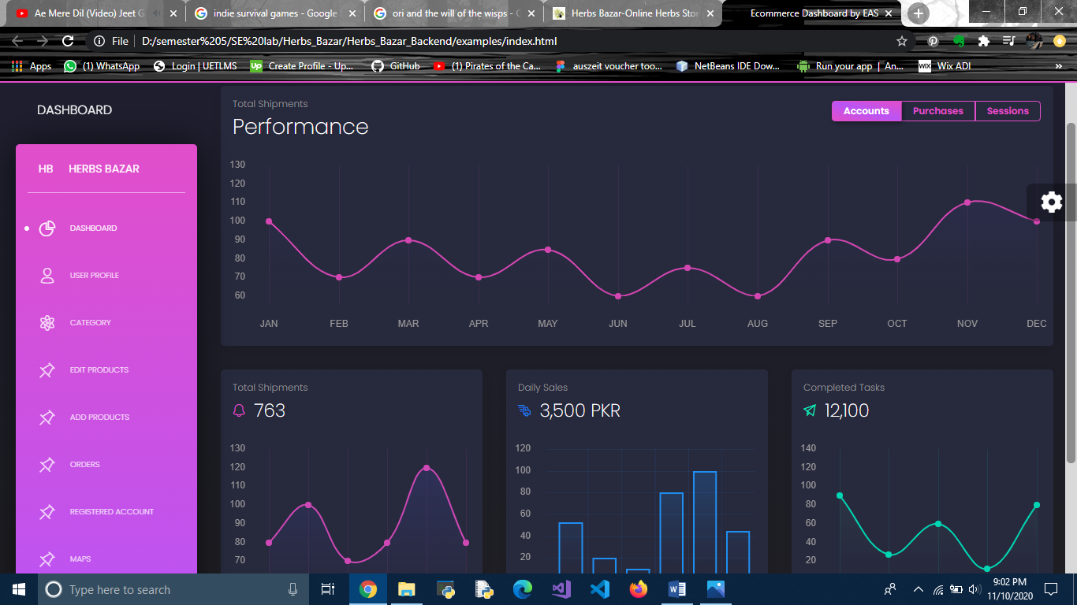

**T1**

**T1**: As an admin, I shall monitor overall performance of the website

Admin User Profile Page

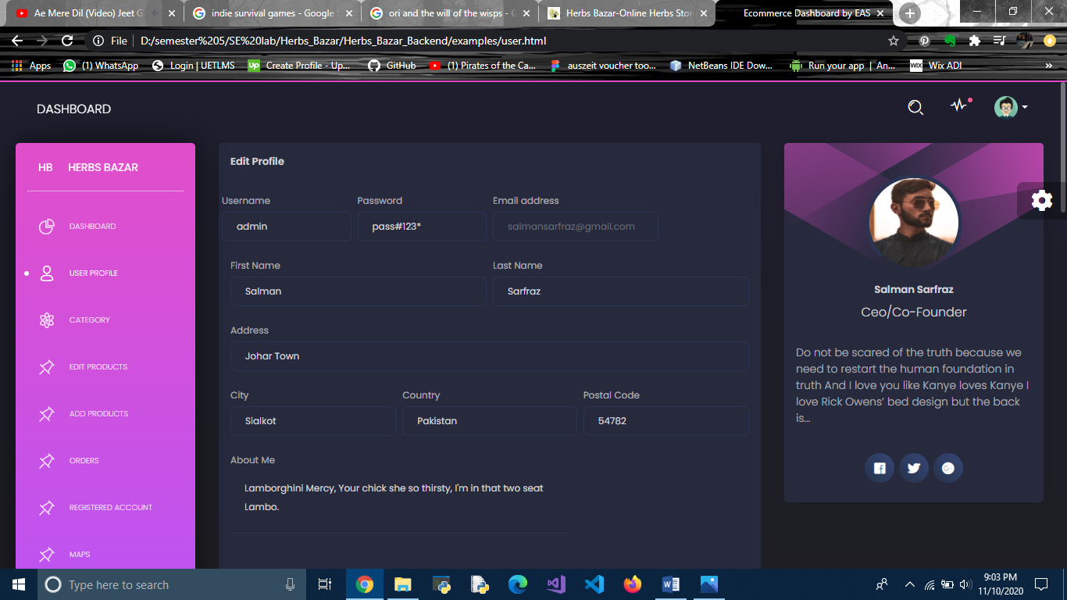

**T1**

**T1**: As an admin, I shall edit user profiles of admins added

Admin Category Page

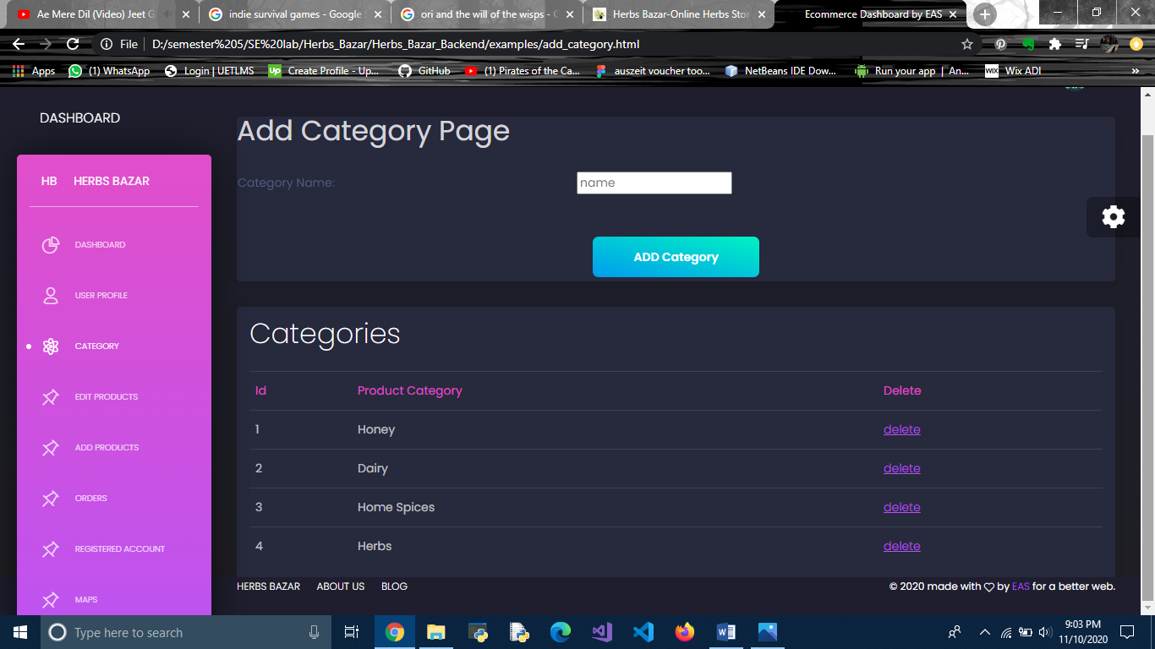

**T2**

**T1**

**T1**: As an admin, I shall add categories.

**T2**: As an admin, I shall delete category.

Admin Edit Products Page

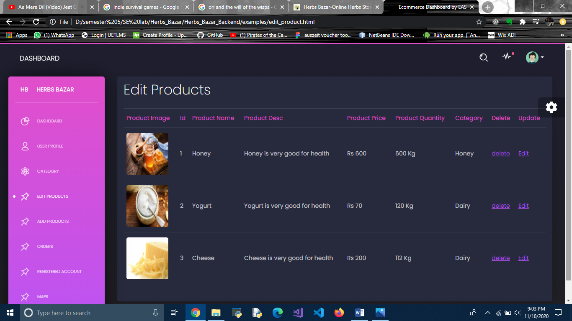

**T2**

**T1**

**T1**: As an admin, I shall delete products.

**T2**: As an admin, I shall edit products.

Admin Edit Product Page

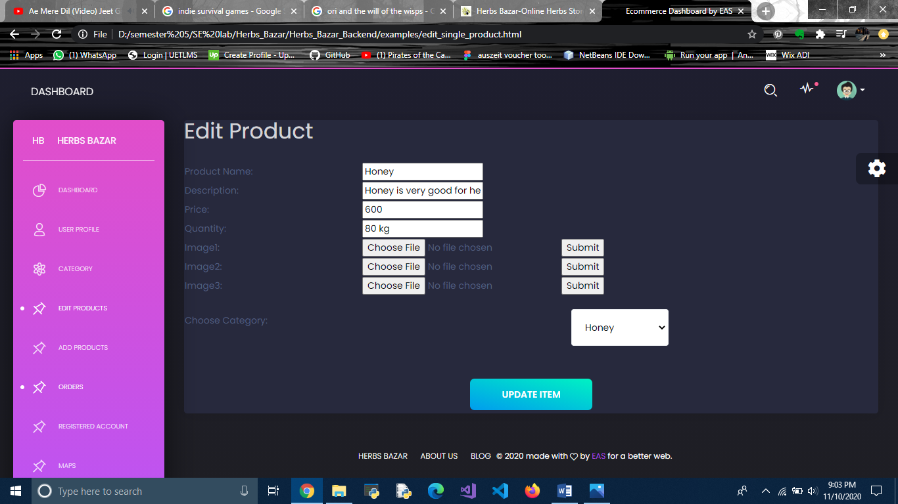

**T1**

**T1**: As an admin, I shall update information of a product and save it.

Admin Add Product Page

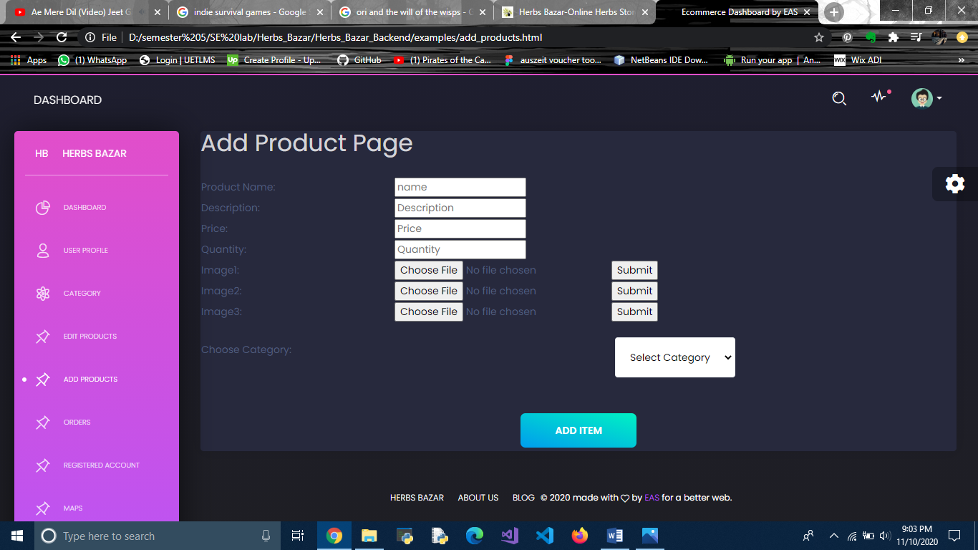

**T1**

**T1**: As an admin, I shall add information of a product and save it.

Admin Orders Page

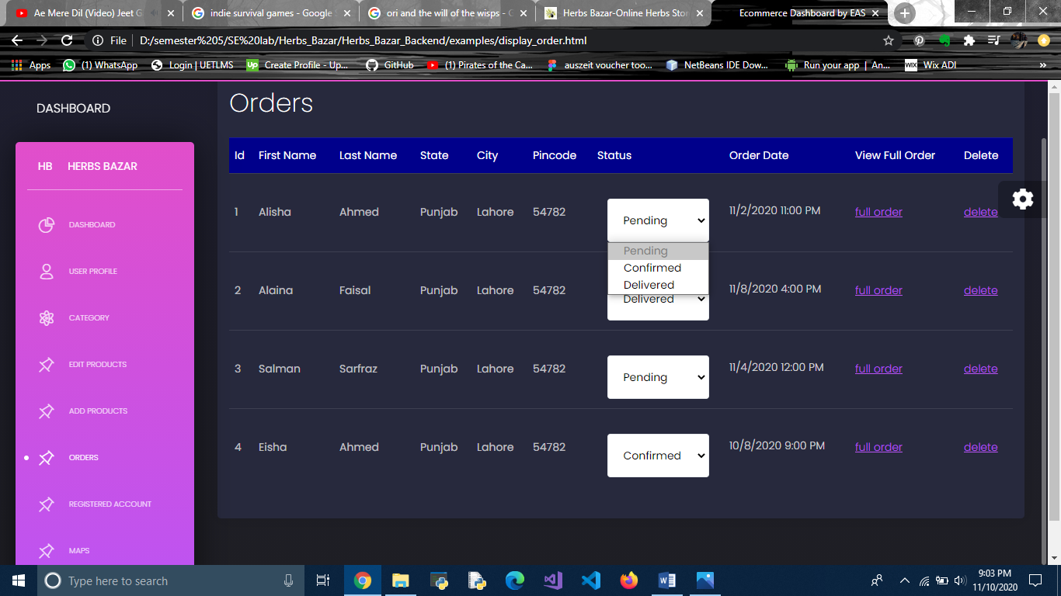

**T2**

**T1**

**T1**: As an admin, I shall change status of order.

**T2**: As an admin, I shall delete an order placed.

Admin View Full Orders Page

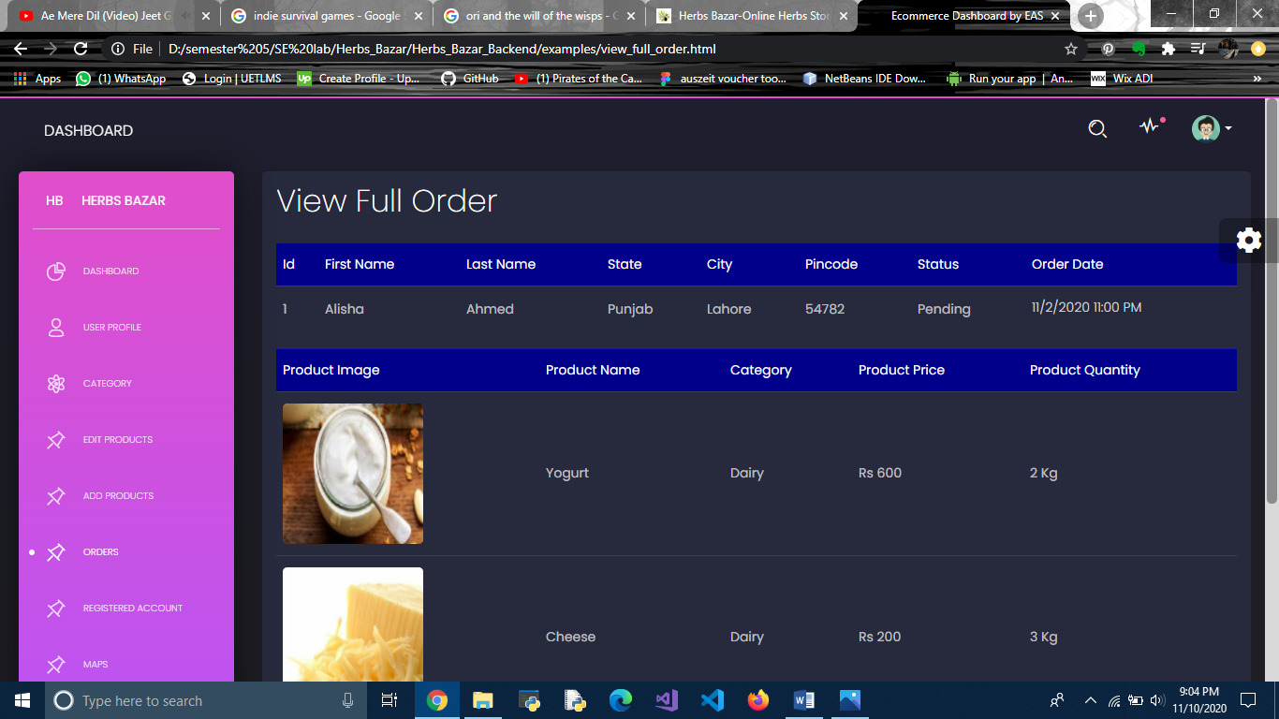

**T1**

**T1**: As an admin, I shall view full details of all orders.

Admin Registered Account Page

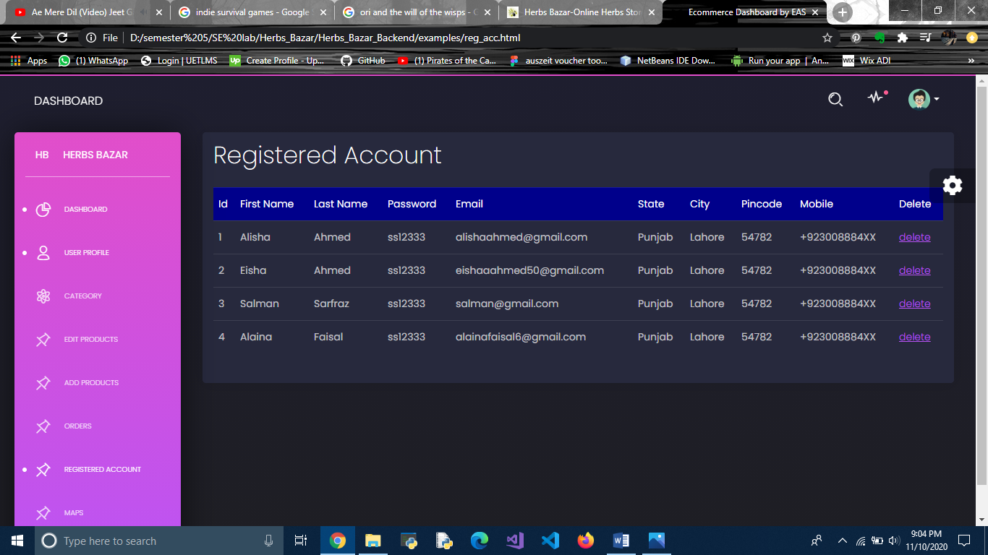

**T1**

**T1**: As an admin, I shall view information of registered accounts and delete them.

User Account Page

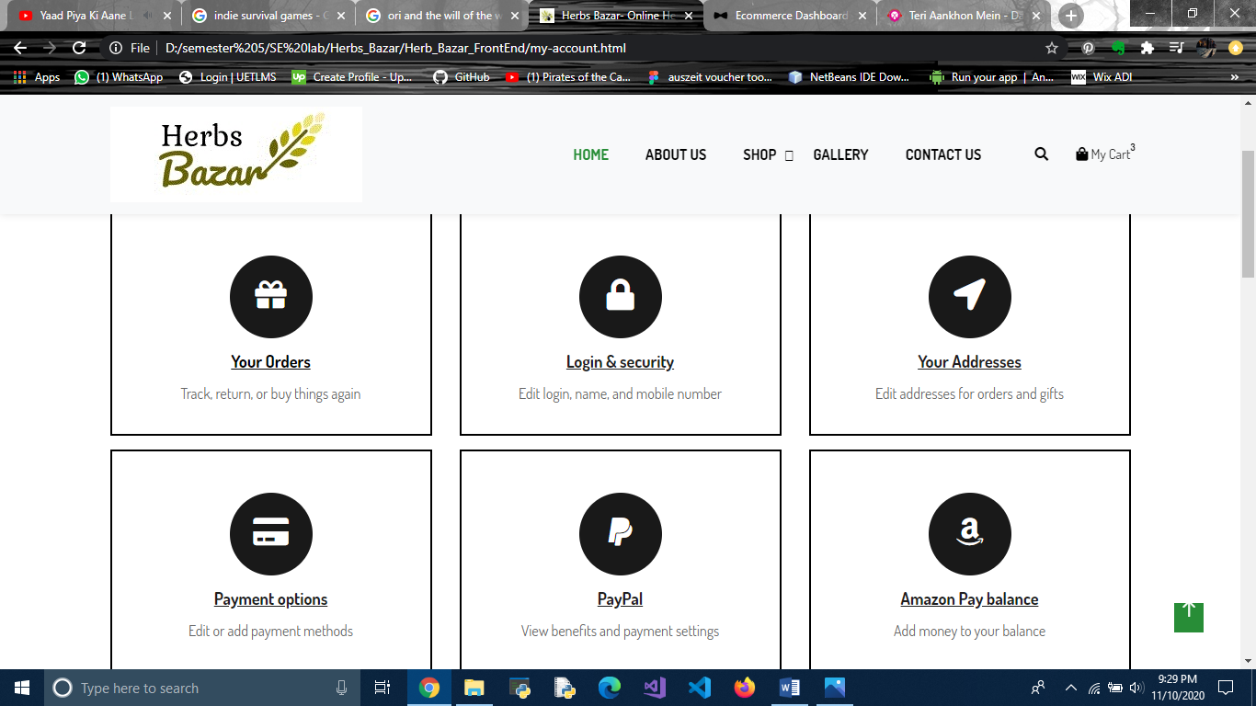

**T1**

**T1**: As a user, I shall view information of registered accounts and delete them.

User My Orders Page

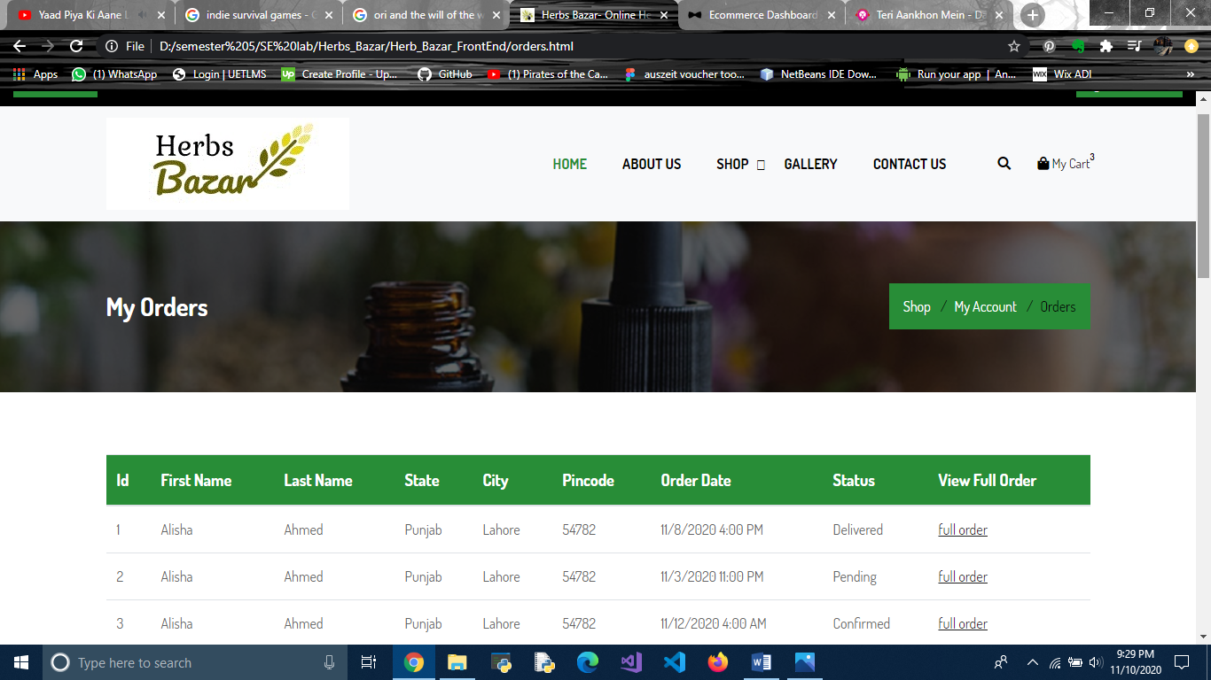

**T1**

**T1**: As a user, I shall view information of all the orders I have placed.

User About Herbs Bazar Page

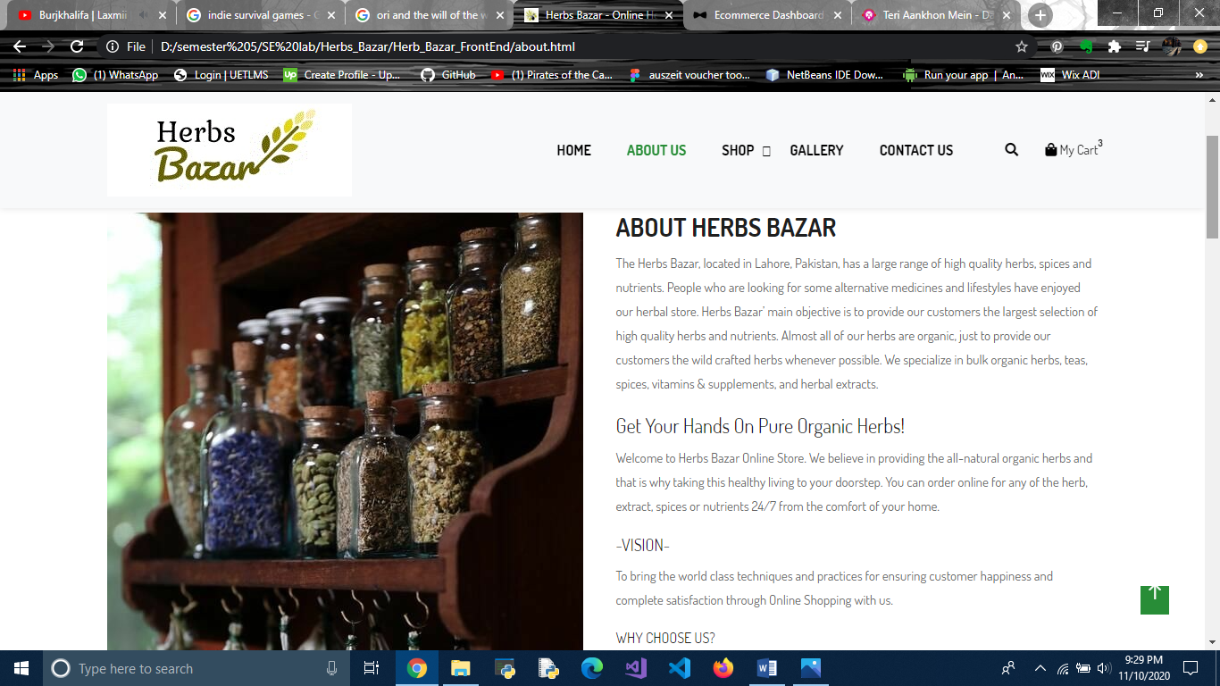

**T1**

**T1**: As a user, I shall view information about the website.

User Contact Us Page

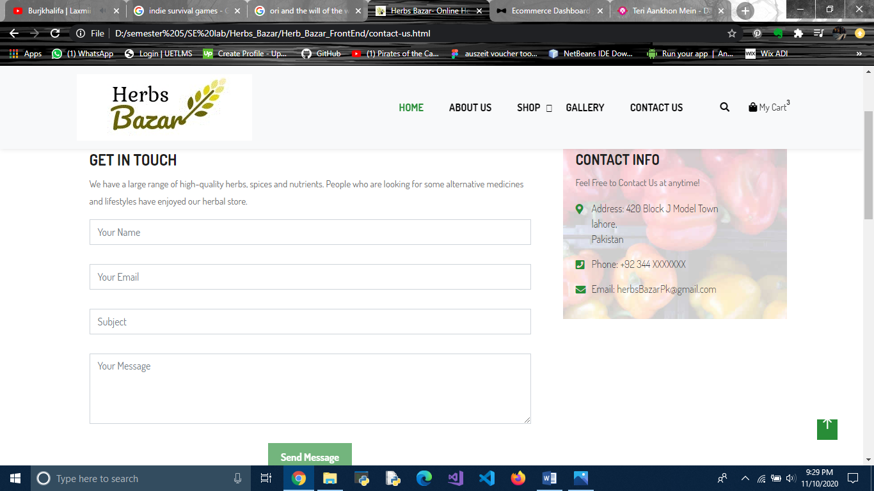

**T1**

**T1**: As a user, I shall view information about the website.

User Gallery Page

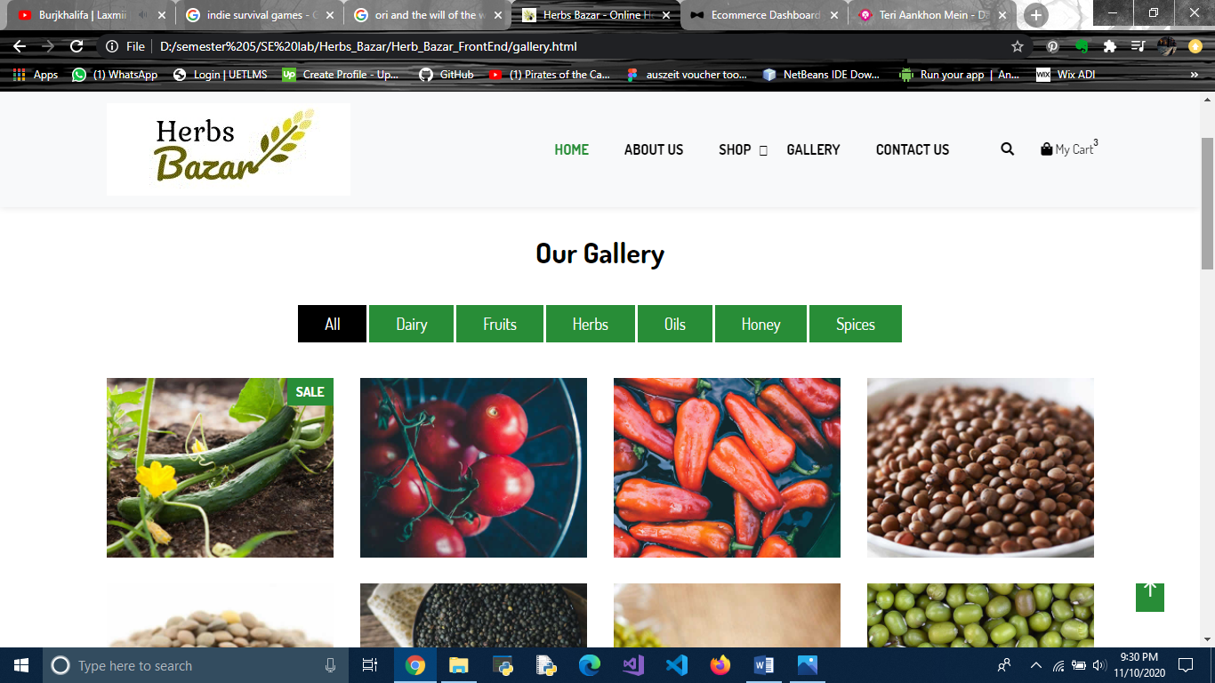

**T1**

**T1**: As a user, I shall view gallery and different products and their categories.

User Home Page

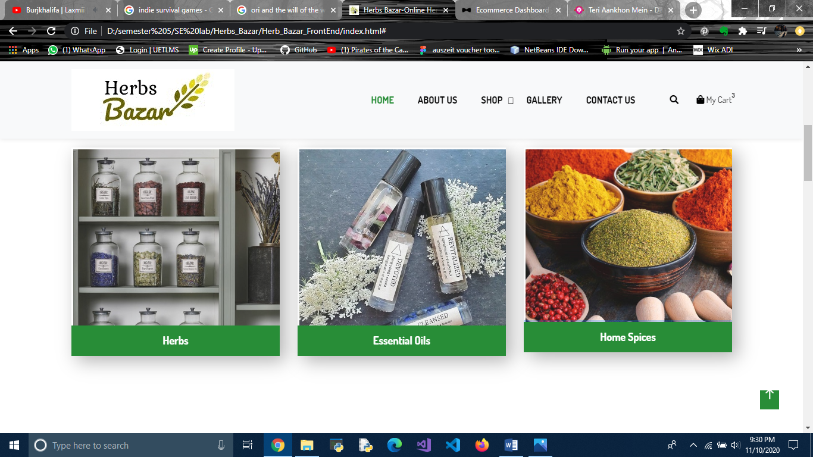

**T1**

**T1**: As a user, I shall view different categories and view products from certain categories.

User Home Page

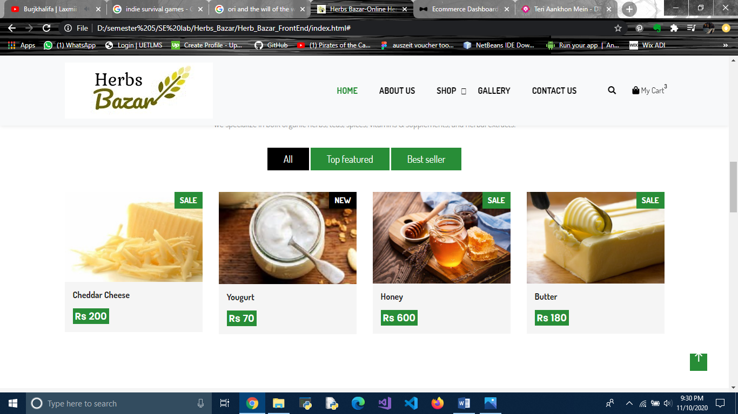

**T1**

**T1**: As a user, I shall view items on sale and browse via filters such as top featured items or best seller items.

User Cart Page

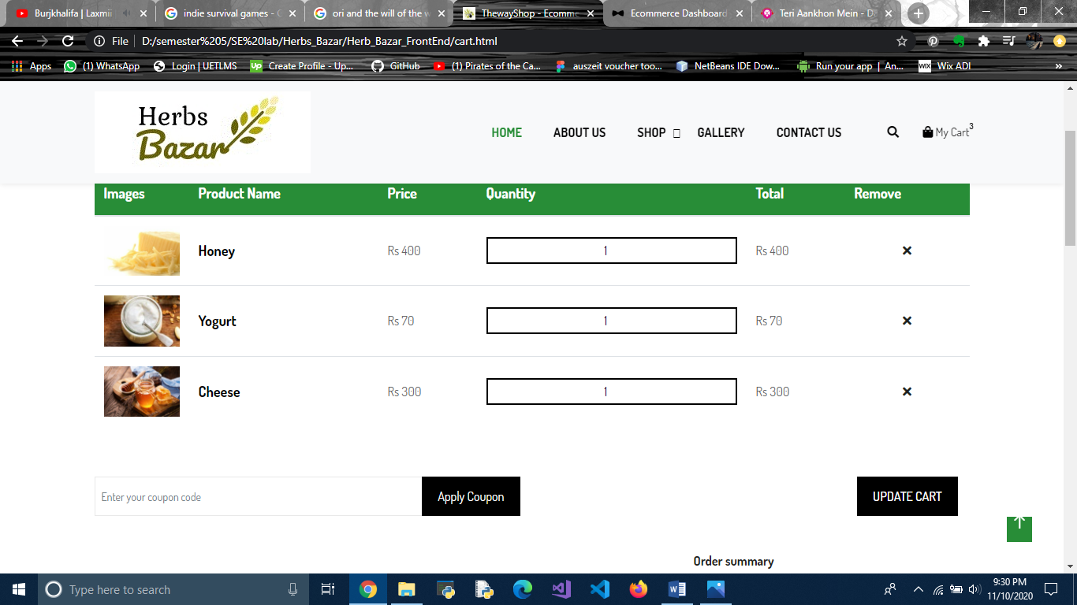

**T1**

**T1**: As a user, I shall view my cart and update information such as remove items or change their quantity.

User Checkout Page

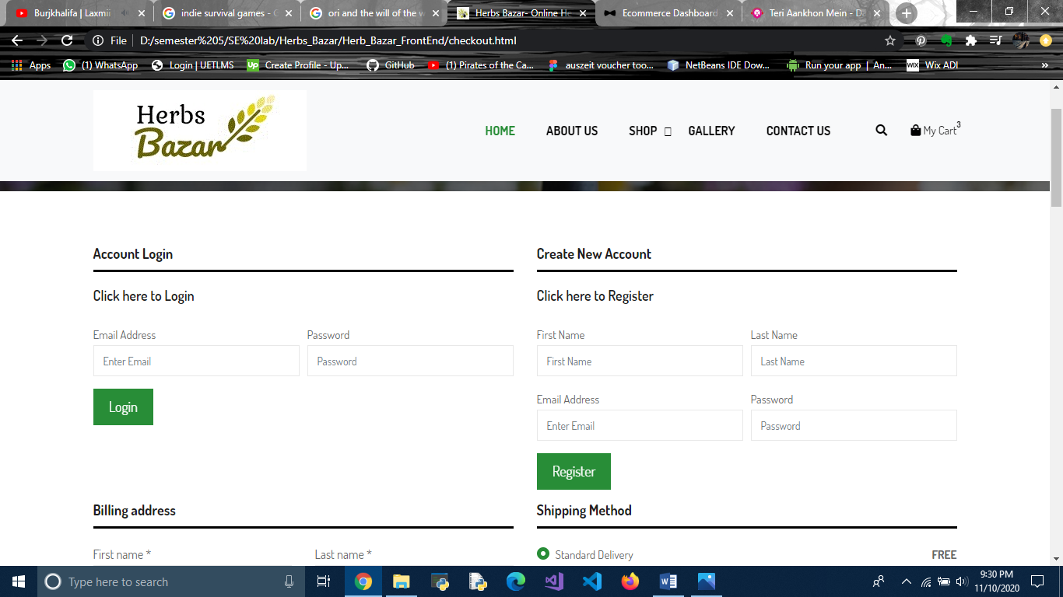

**T1**

**T1**: As a user, I shall either Login or Create New Account to place order.

User Checkout Page

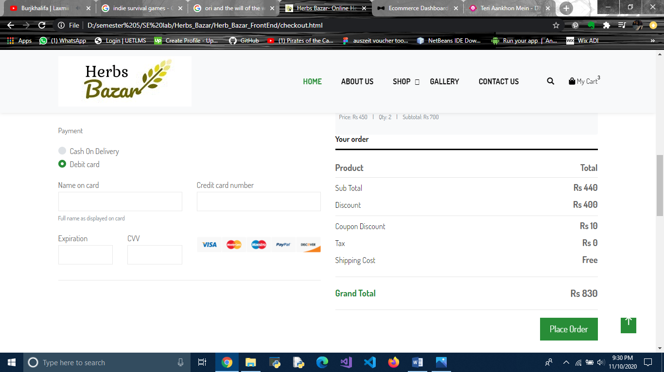

**T1**

**T1**: As a user, I shall enter information in given fields and place an order.

User Wishlist Page

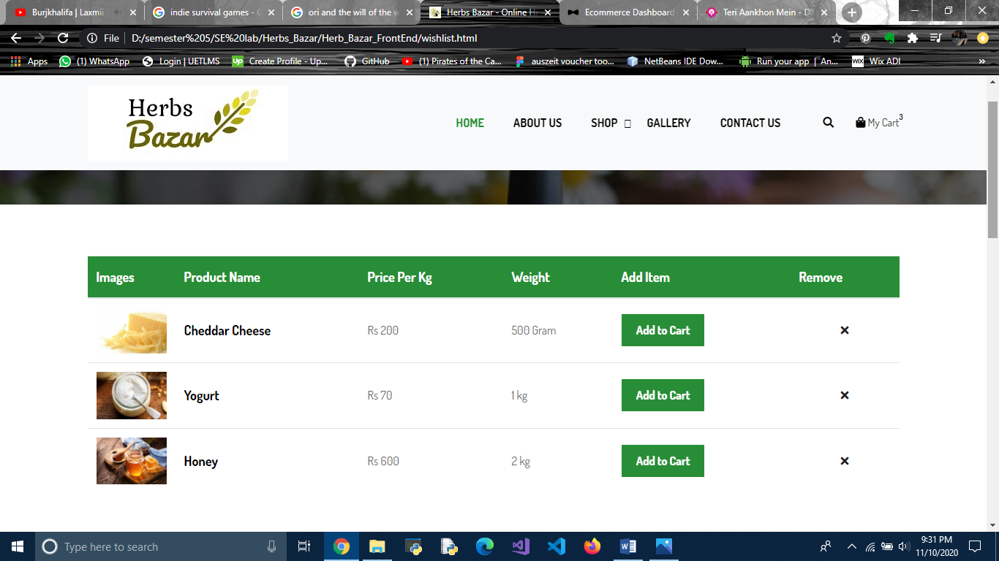

**T1**

**T1**: As a user, I shall view my wishlist and add items to cart or remove them.

User Home Page

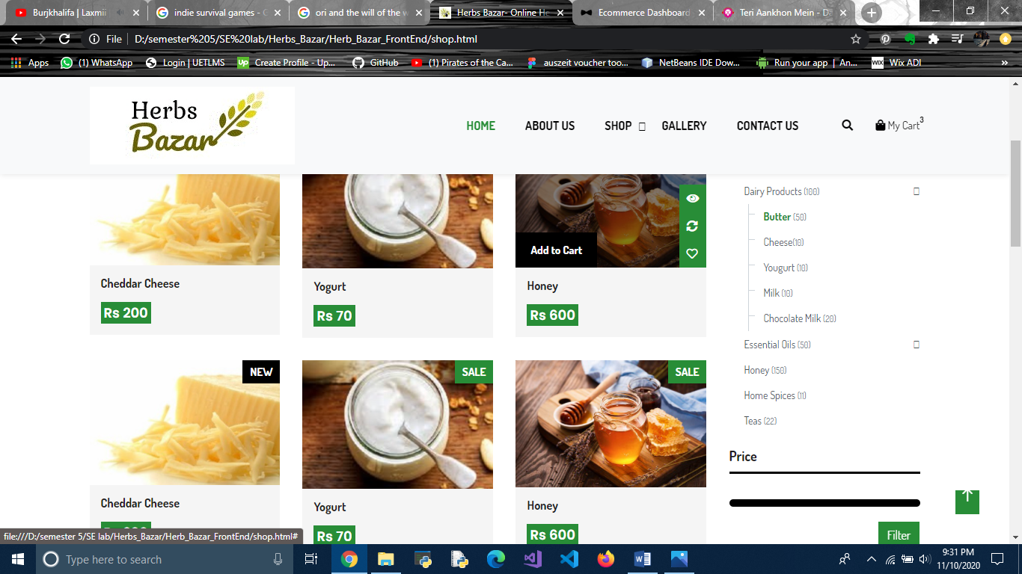

**T1**

**T1**: As a user, I shall view different products and add them to cart.

## Functional Requirements

### User

1. User shall be able to login.
2. User shall be able to sign out.
3. User shall be able to register.
4. User shall be able to view products.
5. User shall be able to add products to cart.
6. User shall be able to checkout and place order.
7. User shall be able to check account.
8. User shall be able to delete products from cart.
9. User shall be able to change quantity of products in cart.
10. User shall be able to view gallery.
11. User shall be able to add to wish list.

### Admin

1. Admin shall be able to login.
2. Admin shall be able to sign out.
3. Admin shall be able to add categories.
4. Admin shall be able to delete categories.
5. Admin shall be able to add products.
6. Admin shall be able to edit products.
7. Admin shall be able to delete products.
8. Admin shall be able edit user profiles.
9. Admin shall be able to view orders.
10. Admin shall be able to delete orders.
11. Admin shall be able to change status of orders.
12. Admin shall be able to view registered users.
13. Admin shall be able to delete registered users.

## Use Cases:

<Provide here the usage scenarios of all use cases in table format explaining Use Case title, Use Case Id, Actions, Description, Alternative Paths, Pre and Post Conditions, Author, Exceptions. You are supposed to provide a usage scenario for each use case shown in the use case diagram. Following is an example for a usage scenario>

|  |  |
| --- | --- |
| **Use Case Title** | **Login** |
| **Use Case Id** | 1 |
| **Requirement Id** | 1 |
| **Description:** This use case is about how user gets access to checkout through login. | |
| **Pre Conditions:**   * 1. User should be on Sign in Page.   2. Database should be available in online mode. | |
| **Normal Flow** | |
| 1. User browses to Sign in Page. | |
| 1. User enters the User Name and Password. | |
| 1. User clicks on Sign In button. | |
| 1. System checks from database if information added is valid. | |
| 1. System provides information based on user class. | |
| **Alternative Flow** | |
| 4a. There is a problem in the data provided; invalid username or password.  System asks user to try again | |
| **Post Conditions:**   * + User gets notified about whether they have logged in or not.   + User gets access to their account. | |
| **Open issues:** If user does not have internet, they can try when internet is available | |
| **Authority:** Administrator, User | |

|  |  |
| --- | --- |
| **Use Case Title** | **Sign Out** |
| **Use Case Id** | 2 |
| **Requirement Id** | 2 |
| **Description:** This use case is about how user can sign out successfully from website. | |
| **Pre Conditions:**   1. User should click on Sign Out button. 2. User should be logged in. | |
| **Normal Flow** | |
| 1. User browses to Sign out button. | |
| 1. User clicks on Sign Out button. | |
| 1. System logs user out and ends session. | |
| **Alternative Flow** | |
| **N/A** | |
| **Post Conditions:**   * + User is logged out | |
| **Open issues:** | |
| **Authority:** Administrator | |

|  |  |
| --- | --- |
| **Use Case Title** | **Register** |
| **Use Case Id** | 3 |
| **Requirement Id** | 3 |
| **Description:** This use case is about how user gets registered in the existing system. | |
| **Pre Conditions:**   * 1. User should be on Register Page.   2. Database should be available in online mode. | |
| **Normal Flow** | |
| 1. User browses to register page. | |
| 1. User enters the data in all fields. | |
| 1. User clicks on Sign Up button. | |
| 1. System checks the validity of information added and adds the account into database. | |
| 1. User gets notified of account creation. | |
| **Alternative Flow** | |
| 4a. There is a problem in the data provided; data is invalid.  System asks user to try again | |
| **Post Conditions:**   * + User gets notified about whether they have been registered or not.   + User gets access to their account. | |
| **Open issues:** If user does not have internet, they can try when internet is available | |
| **Authority:** Administrator, User | |

|  |  |
| --- | --- |
| **Use Case Title** | **View products** |
| **Use Case Id** | 4 |
| **Requirement Id** | 4 |
| **Description:** This use case is about how user can view the products available on the website and their costs. | |
| **Pre Conditions:**   * 1. User should be on Website. | |
| **Normal Flow** | |
| 1. User opens website. | |
| 1. User views products. | |
| **Alternative Flow** | |
| N/A | |
| **Post Conditions:**  N/A | |
| **Open issues:** If user does not have internet, they can try when internet is available | |
| **Authority:** Administrator, User | |

|  |  |
| --- | --- |
| **Use Case Title** | **Add products to cart** |
| **Use Case Id** | 5 |
| **Requirement Id** | 5 |
| **Description:** This use case is about how user can add the products available on the website to their carts. | |
| **Pre Conditions:**   1. User should have pressed the Add to Cart button. | |
| **Normal Flow** | |
| 1. User opens website. | |
| 1. User views products. | |
| 1. User presses the Add to Cart button. | |
| 1. The product is added to the cart of user in session. | |
| **Alternative Flow** | |
| N/A | |
| **Post Conditions:**  Product is added to user’s cart | |
| **Open issues: N/A** | |
| **Authority:** Administrator, User | |

|  |  |
| --- | --- |
| **Use Case Title** | **Checkout to place order** |
| **Use Case Id** | 6 |
| **Requirement Id** | 6 |
| **Description:** This use case is about how user can check out with the current items in cart and place an order. | |
| **Pre Conditions:**   1. User has added products in cart. 2. User has all the information required to be filled to check out. | |
| **Normal Flow** | |
| 1. User presses check out button | |
| 1. User is navigated to check out page. | |
| 1. User log in or registers. | |
| 1. User enters data in given fields. | |
| 1. User presses Checkout button. | |
| 1. System registers user’s order and notifies admin | |
| **Alternative Flow** | |
| 1.a User opens check out page from Shop drop down | |
| **Post Conditions:**  User is notified of whether order is placed or not | |
| **Open issues: N/A** | |
| **Authority:** Administrator, User | |

|  |  |
| --- | --- |
| **Use Case Title** | **Check account** |
| **Use Case Id** | 7 |
| **Requirement Id** | 7 |
| **Description:** This use case is about how user can check out with the current items in cart and place an order. | |
| **Pre Conditions:**   1. User is logged in | |
| **Normal Flow** | |
| 1. User presses My account from Shop dropdown | |
| 1. User is navigated to his/her account page | |
| **Alternative Flow** | |
| N/A | |
| **Post Conditions:**  User views their account | |
| **Open issues: N/A** | |
| **Authority:** Administrator, User | |

|  |  |
| --- | --- |
| **Use Case Title** | **Delete product from cart** |
| **Use Case Id** | 8 |
| **Requirement Id** | 8 |
| **Description:** This use case is about how user can delete a product from cart. | |
| **Pre Conditions:**   1. User has added products in cart. | |
| **Normal Flow** | |
| 1. User presses cart button | |
| 1. User is navigated to their cart. | |
| 1. User presses delete button. | |
| 1. Product is removed from User’s cart. | |
| **Alternative Flow** | |
| N/A | |
| **Post Conditions:**  User views updated cart | |
| **Open issues: N/A** | |
| **Authority:** Administrator, User | |

|  |  |
| --- | --- |
| **Use Case Title** | **Change quantity of product in cart** |
| **Use Case Id** | 10 |
| **Requirement Id** | 10 |
| **Description:** This use case is about how user can change quantity of product in cart. | |
| **Pre Conditions:**   1. User has added products in cart. | |
| **Normal Flow** | |
| 1. User presses cart button | |
| 1. User is navigated to their cart. | |
| 1. User presses + or -. | |
| 1. Product quantity in increased or decreased from User’s cart. | |
| **Alternative Flow** | |
| N/A | |
| **Post Conditions:**  User views updated cart | |
| **Open issues: N/A** | |
| **Authority:** Administrator, User | |

|  |  |
| --- | --- |
| **Use Case Title** | **Add items to wishlist** |
| **Use Case Id** | 11 |
| **Requirement Id** | 11 |
| **Description:** This use case is about how user can add items to wishlist that they view on website. | |
| **Pre Conditions:**   1. User has internet connection. | |
| **Normal Flow** | |
| 1. User presses add to wishlist button. | |
| 1. Items is added to user’s wishlist. | |
| **Alternative Flow** | |
| N/A | |
| **Post Conditions:**  Product available in user wishlist | |
| **Open issues: N/A** | |
| **Authority:** Administrator, User | |

|  |  |
| --- | --- |
| **Use Case Title** | **Login** |
| **Use Case Id** | 12 |
| **Requirement Id** | 12 |
| **Description:** This use case is about how admin gets access to admin panel through login. | |
| **Pre Conditions:**   * 1. Admin should be on Sign in Page.   2. Database should be available in online mode. | |
| **Normal Flow** | |
| 1. Admin browses to Sign in Page. | |
| 1. Admin enters the User Name and Password. | |
| 1. Admin clicks on Sign In button. | |
| 1. System checks from database if information added is valid. | |
| 1. System provides information based on user class. | |
| **Alternative Flow** | |
| 4a. There is a problem in the data provided; invalid username or password.  System asks user to try again | |
| **Post Conditions:**   * + Admin gets notified about whether they have logged in or not.   + Admin gets access to their account. | |
| **Open issues:** | |
| **Authority:** Administrator, User | |

|  |  |
| --- | --- |
| **Use Case Title** | **Sign Out** |
| **Use Case Id** | 13 |
| **Requirement Id** | 13 |
| **Description:** This use case is about how admin can sign out successfully from website. | |
| **Pre Conditions:**   1. Admin should click on Sign Out button. 2. Admin should be logged in. | |
| **Normal Flow** | |
| 1. Admin browses to Sign out button. | |
| 1. Admin clicks on Sign Out button. | |
| 1. System logs user out and ends session. | |
| **Alternative Flow** | |
| **N/A** | |
| **Post Conditions:**   * + Admin is logged out | |
| **Open issues:** | |
| **Authority:** Administrator | |

|  |  |
| --- | --- |
| **Use Case Title** | **Add categories** |
| **Use Case Id** | 14 |
| **Requirement Id** | 14 |
| **Description:** This use case is about how admin can add the categories available on the website. | |
| **Pre Conditions:**   1. Admin should be logged in. 2. Admin is on Category Page | |
| **Normal Flow** | |
| 1. Admin presses Add category button. | |
| 1. Admin adds information about the category. | |
| 1. Admin presses the Add button. | |
| **Alternative Flow** | |
| N/A | |
| **Post Conditions:**  Category is added. | |
| **Open issues: N/A** | |
| **Authority:** Administrator | |

|  |  |
| --- | --- |
| **Use Case Title** | **Delete categories** |
| **Use Case Id** | 15 |
| **Requirement Id** | 15 |
| **Description:** This use case is about how admin can delete the categories available on the website. | |
| **Pre Conditions:**   1. Admin should be logged in. 2. Admin is on Category Page. | |
| **Normal Flow** | |
| 1. Admin presses delete button. | |
| **Alternative Flow** | |
| N/A | |
| **Post Conditions:**  Category is deleted. | |
| **Open issues: N/A** | |
| **Authority:** Administrator | |

|  |  |
| --- | --- |
| **Use Case Title** | **Add products** |
| **Use Case Id** | 16 |
| **Requirement Id** | 16 |
| **Description:** This use case is about how admin can add the products available on the website. | |
| **Pre Conditions:**   1. Admin should be logged in. 2. Admin is on Add products Page | |
| **Normal Flow** | |
| 1. Admin adds information about the product. | |
| 1. Admin presses the Add item button. | |
| **Alternative Flow** | |
| N/A | |
| **Post Conditions:**  Product is added. | |
| **Open issues: N/A** | |
| **Authority:** Administrator | |

|  |  |
| --- | --- |
| **Use Case Title** | **Edit products** |
| **Use Case Id** | 17 |
| **Requirement Id** | 17 |
| **Description:** This use case is about how admin can edit the products available on the website. | |
| **Pre Conditions:**   1. Admin should be logged in. 2. Admin is on Edit Products Page | |
| **Normal Flow** | |
| 1. Admin presses edit button. | |
| 1. Admin is navigated to edit category page. | |
| 1. Admin adds information to be edited. | |
| 1. Admin presses Update button. | |
| 1. Information is updated in system | |
| **Alternative Flow** | |
| N/A | |
| **Post Conditions:**  Product is updated on website. | |
| **Open issues: N/A** | |
| **Authority:** Administrator | |

|  |  |
| --- | --- |
| **Use Case Title** | **Delete products** |
| **Use Case Id** | 18 |
| **Requirement Id** | 18 |
| **Description:** This use case is about how admin can delete the products available on the website. | |
| **Pre Conditions:**   1. Admin should be logged in. 2. Admin is on Edit Products Page | |
| **Normal Flow** | |
| 1. Admin presses delete button. | |
| 1. Information is updated in system | |
| **Alternative Flow** | |
| N/A | |
| **Post Conditions:**  Product is deleted on website. | |
| **Open issues: N/A** | |
| **Authority:** Administrator | |

|  |  |
| --- | --- |
| **Use Case Title** | **Edit user profiles** |
| **Use Case Id** | 19 |
| **Requirement Id** | 19 |
| **Description:** This use case is about how admin can edit user profiles. | |
| **Pre Conditions:**   1. Admin should be logged in. 2. Admin is on User Profile Page | |
| **Normal Flow** | |
| 1. Admin changes the information in fields to be edited. | |
| 1. Admin presses Save button. | |
| 1. Information is updated in system | |
| **Alternative Flow** | |
| N/A | |
| **Post Conditions:**  Profile is updated | |
| **Open issues: N/A** | |
| **Authority:** Administrator | |

|  |  |
| --- | --- |
| **Use Case Title** | **View Order** |
| **Use Case Id** | 20 |
| **Requirement Id** | 20 |
| **Description:** This use case is about how admin can view orders placed by a user. | |
| **Pre Conditions:**   1. Admin should be logged in. 2. Admin is on Orders Page | |
| **Normal Flow** | |
| 1. Admin presses View full order button. | |
| 1. Admin is navigated to View full order page. | |
| **Alternative Flow** | |
| N/A | |
| **Post Conditions:**  Order is viewed by Admin | |
| **Open issues: N/A** | |
| **Authority:** Administrator | |

|  |  |
| --- | --- |
| **Use Case Title** | **Delete Order** |
| **Use Case Id** | 21 |
| **Requirement Id** | 21 |
| **Description:** This use case is about how admin can delete orders placed by a user. | |
| **Pre Conditions:**   1. Admin should be logged in. 2. Admin is on Orders Page | |
| **Normal Flow** | |
| 1. Admin presses delete button. | |
| 1. Information is updated in database. | |
| **Alternative Flow** | |
| N/A | |
| **Post Conditions:**  User notified of the order cancellation. | |
| **Open issues: N/A** | |
| **Authority:** Administrator | |

|  |  |
| --- | --- |
| **Use Case Title** | **Update status of Order** |
| **Use Case Id** | 22 |
| **Requirement Id** | 22 |
| **Description:** This use case is about how admin can update order status placed by a user. | |
| **Pre Conditions:**   1. Admin should be logged in. 2. Admin is on Orders Page | |
| **Normal Flow** | |
| 1. Admin presses selects an option from dropdown. | |
| 1. Information is updated in database. | |
| **Alternative Flow** | |
| N/A | |
| **Post Conditions:**  User notified of the order status. | |
| **Open issues: N/A** | |
| **Authority:** Administrator | |

|  |  |
| --- | --- |
| **Use Case Title** | **View registered users** |
| **Use Case Id** | 23 |
| **Requirement Id** | 23 |
| **Description:** This use case is about how admin can view registered user. | |
| **Pre Conditions:**   1. Admin should be logged in. | |
| **Normal Flow** | |
| 1. Admin presses Registered Account button from side panel. | |
| 1. Admin is navigated to Registered Account page. | |
| **Alternative Flow** | |
| N/A | |
| **Post Conditions:**  Accounts are visible to admin. | |
| **Open issues: N/A** | |
| **Authority:** Administrator | |

|  |  |
| --- | --- |
| **Use Case Title** | **Delete registered users** |
| **Use Case Id** | 24 |
| **Requirement Id** | 24 |
| **Description:** This use case is about how admin can delete registered user. | |
| **Pre Conditions:**   1. Admin should be logged in. | |
| **Normal Flow** | |
| 1. Admin presses Registered Account button from side panel. | |
| 1. Admin is navigated to Registered Account page. | |
| 1. Admin presses delete button. | |
| 1. Information updated in database | |
| **Alternative Flow** | |
| N/A | |
| **Post Conditions:**  Accounts deleted | |
| **Open issues: N/A** | |
| **Authority:** Administrator | |

## Non Functional Requirements:

# Interface:

* Should be user friendly and easy to use
* There should be an image for all products available

# Performance

* System should be able to uphold large amount of data without crashing.
* System speed will depend on user’s internet speed and hardware components.

# Security

* System should secure sockets in all transactions that include any confidential customer information.
* User’s information and data should be kept confidential and not shared with any third party.
* System should confirm order with user through contact information provided.
* System’s backend should not display user’s password.

# Usability

* When user will log in, his/her account information will be provided with all functionalities and dealt with.

# Project Work Plan

